September 11, 2001 Croton Falls Volunteer Fire Department Response
On September 11, 2001 the Croton Falls Volunteer Fire Department was dispatched at approximately 10:07 a.m. by 60 control to respond to the firefighter training center in Valhalla. This dispatch was part of a massive mutual-aid response to the terrorist attacks on the World Trade Center in lower Manhattan. Mutual-aid companies from all over Westchester County were dispatched. Companies were dispatched to both the fire training center in Valhalla and Yonkers Raceway. Croton Falls was one of many Fire and EMS departments that responded to the fire training center in Valhalla that day. The department responded to the training center with three full crews on Engine 148, Engine 149, and Rescue 28. Throughout the morning and during the day other firefighters responded and remained on standby at both the Croton Falls and North Salem fire stations. Crews had both Tanker 8 and old Engine 149 on standby. Old Engine 149 was placed back into service that day so the crew could respond if necessary. At the training center the firefighters witnessed one of the greatest mutual-aid responses as well as fighter jets and military helicopters flying overhead. A military helicopter even landed right next to the training center. The firefighters remained on standby at the training center and in Croton Falls all day and well into the night until they were released. Another day Engine 149 and a crew were sent to standby and help respond to calls at 3431 White Plains Rd. Engine Company 62/Ladder Company 32 in the Bronx. While on standby they responded to various emergency calls. Additionally, the Croton Falls Volunteer Fire Department with Engine 149 attended a memorial service for a member of our town, fallen firefighter Lieutenant Vincent Halloran of Ladder 8 FDNY at St. Patrick’s Cathedral.
- Source: Responding department members accounts written 2018
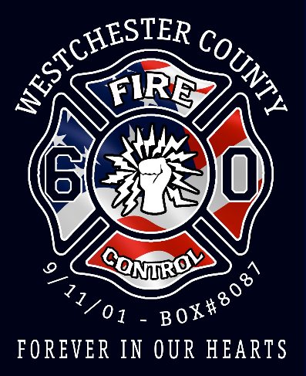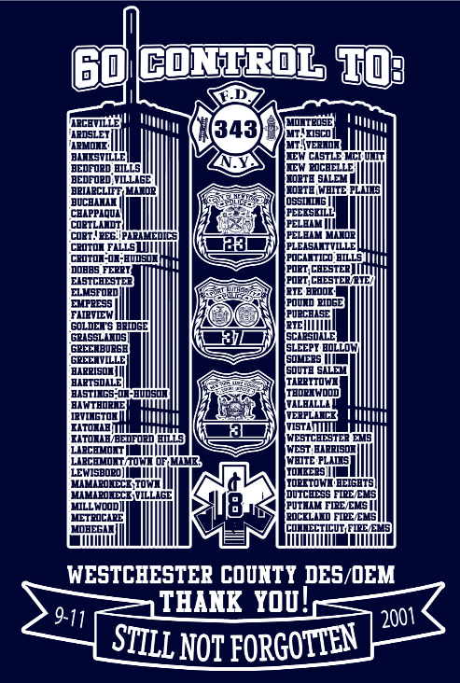
FDNY Fire Operations response on September 11

Mutual aid request brings Nassau and Westchester units
Before September 11, the FDNY had rarely requested mutual aid from departments outside the city to support fire operations. The Department had no process for evaluating the need for mutual aid, nor any formal methods of requesting that aid or managing it. Therefore, the Department had limited ability to evaluate how mutual aid could be integrated into its operations. However, due to the magnitude of the WTC incident, FDNY personnel sought mutual aid from Westchester County at approximately 10:07 a.m., and from Nassau County at 10:23 a.m. These initial mutual aid requests did not specify the level and type of resources needed. In addition, the FDNY did not have adequate information on the resources and capabilities of departments in surrounding cities and counties (e.g., the size, capabilities and expertise of different units). And, the FDNY had minimal operational training with surrounding fire departments, and hence had limited ability to evaluate whether and how resources from other departments could be integrated with the FDNY’s operations. For instance, it could not tell whether procedures could be integrated, equipment could interoperate, and whether the capabilities of units with the same names (e.g., rescue or hazmat) were comparable. Our interviews and review of dispatch tapes indicate that mutual aid received from neighboring fire departments on September 11 consisted primarily of engine and ladder units. Some mutual aid units deployed to staging areas. Some deployed directly to the incident and others were paired with FDNY units to help maintain citywide coverage.
- Source: FDNY Report 2017 http://www.nyc.gov/html/fdny/pdf/mck_report/fire_operations_response.pdf

